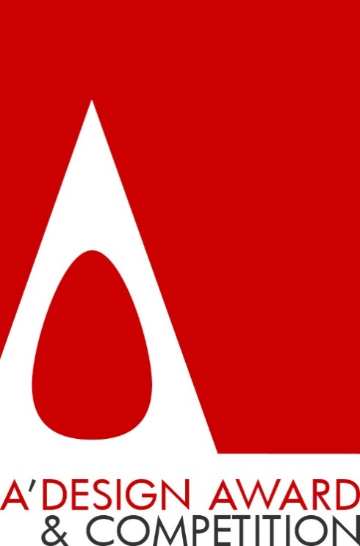
Call for Entries to A' Design Award & Competition
A’ (A-Prime) Design Award & Competition is the world’s leading international annual juried competition for design. The A’ Design Accolades are organized in a wide range of creative fields to highlight the very best designers from all countries in all disciplines. Entries to the competition are peer-reviewed and anonymously judged by an influential jury panel of experienced academics, prominent press members and established professionals. A’ Design Award & Competition promises fame, prestige, publicity and international recognition to all A’ Design Award Winners through the A’ Design Prize which is given to celebrate the awarded designs.
The “A’ Design Prize” is a coveted and comprehensive winners’ kit for awarded designs. “A’ Design Prize” includes but not limited to: international design excellence certificate in metal frame, invitation to the exclusive gala-night in Italy, online + offline exhibition of awarded projects, A2 poster of awarded projects, hardcover printed best projects’ yearbook publication, special 3d printed metal award trophy in luxury black box, project translation to 20+ languages in order to truly reach international audiences, an exclusive interview with the winner, press release preparation and distribution, license to use “A’ Design Award Winner Logo” in your communication, promotion of awarded works to thousands of other publications, media appearances through our press partners, inclusion in World Design Rankings as well as access to further marketing and PR tools.
The A’ Design Award & Competition has been established to promote and recognize the best design works in all countries and in all creative disciplines. The primary aim of the A’ Design Award & Competition is to create a global awareness and understanding for good design practices and principles by highlighting best designs in all countries and in all industrial fields. The ultimate aim of the A’ Design Awards is to push designers and brands worldwide to create superior products and projects that benefit the society.
The A’ Design Award & Competition has a philanthropic goal to advance society by pushing the frontiers of science, design, creativity and technology. The A’ Design Competition aims to create incentives and programs to ignite and reward creativity, original ideas and concept generation in all industrial sectors. The “A’ Design Award Winner” logo, given to award winning designs, signifies original, functional and efficient designs that help the world become a better place.
Every year, projects that focus on innovation, technology, design and creativity are awarded with the A' Design Award. Entries are accepted annually till February 28th and results are announced every year on April 15. Designers worldwide are called to take part in the accolades by entering their best works, projects and products. Entries are accepted as long as they were designed in the last 10 years.
Learn more about the A’ Design Awards
Check out the A’ Design Award Presentation: http://www.designaward.com
In-depth Presentation of A’ Design Accolades: http://www.whatisadesignaward.com
Browse award winning designs: http://www.awardeddesigns.com
Access Press-Kits of award winning works and projects: http://www.press-kit.org
Read Interviews with Award Winning Designers: http://www.design-interviews.com
Enter your works to the A’ Design competition at: http://www.adesignaward.com/registration.php
Discover World Design Rankings: http://www.worlddesignrankings.com
Download A’ Design Award Logo & Editorial Images: https://www.adesignaward.com/downloads.html

